Experiment-7

Aim
To read and display a captured video in normal speed, slow motion, and fast motion using Python and OpenCV.

Procedure
- Import the OpenCV library.
- Open the captured video using cv2.VideoCapture().
- Check whether the video is opened successfully.
- Read and display the video frame by frame.
- Use a longer delay between frames to display the video in slow motion.
- Use a shorter delay between frames to display the video in fast motion.
- Release the video capture object and close all windows.

Code
import cv2
cap = cv2.VideoCapture("video.mp4")
if not cap.isOpened():
print("Error: Cannot open video")
exit()
fps = cap.get(cv2.CAP_PROP_FPS)
while True:
ret, frame = cap.read()

if not ret:
break

cv2.imshow("Normal Speed", frame)
if cv2.waitKey(max(1, int(1000 / fps))) & 0xFF == ord('q'):
break
cap.release()cv2.destroyAllWindows()
# Slow motioncap = cv2.VideoCapture("video.mp4")
while cap.isOpened():
ret, frame = cap.read()

if not ret:
break

cv2.imshow("Slow Motion", frame)
if cv2.waitKey(100) & 0xFF == ord('q'):
break
cap.release()cv2.destroyAllWindows()
# Fast motioncap = cv2.VideoCapture("video.mp4")
while cap.isOpened():
ret, frame = cap.read()

if not ret:
break

cv2.imshow("Fast Motion", frame)
if cv2.waitKey(1) & 0xFF == ord('q'):
break
cap.release()cv2.destroyAllWindows()

Sample Input
A captured video named video.mp4.

Sample Output
- Normal motion: Video plays at approximately its original frame rate.
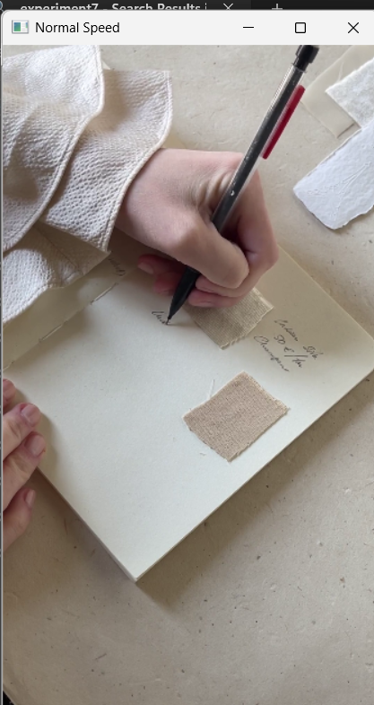
- Slow motion: Video plays more slowly due to a longer delay between frames.
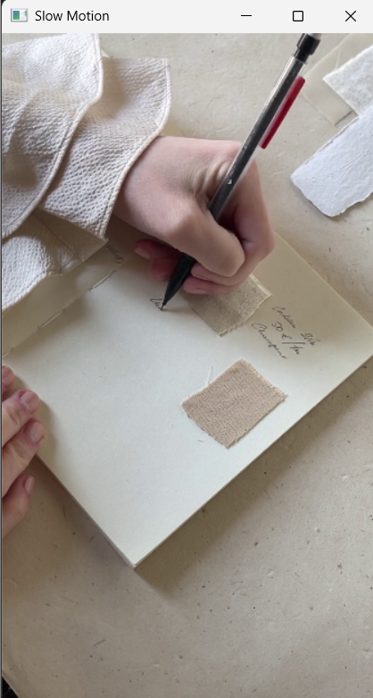
- Fast motion: Video plays faster due to a shorter delay between frames.
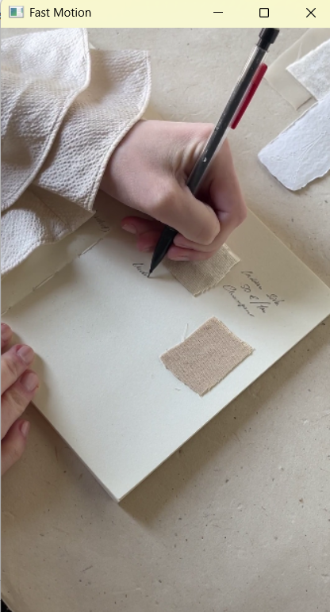

Result
Thus, the captured video was successfully read and displayed at normal, slow, and fast speeds using Python and OpenCV.

